Annual Practical List
Class XII (Computer Science) 2014-15

- Write a program to input n numbers and to insert any number in a ascending sorted list.
- Write a program to convert decimal number to binary,octal & hexadecimal depend upon choice.
- Write a program to input two complex numbers and to find sum of the given complex numbers
(Using Classes and Object )
- Write a program to find all prime numbers up to given number.
- Write a program to find sum of two distances with feet and inches. (Using Classes and Object )
- Write a program to find difference between two times with hours, minutes and seconds.
( Using Classes and Object)
7)Create the class SOCIETY with following information:
society_name,house_no,no_of_members,flat,income
Methods
An __init__ method to assign initial values of society_name as "Surya Apartments", flat as "A Type", house_no as 20, no_of_members as 3, income as 25000.
Inputdata( ) - to read data members(society,house_no,no_of_members&income) and call allocate_flat().
allocate_flat( ) - To allocate flat according to income
Income Flat
>=25000 A Type
>=20000 and <25000 B Type
>15000 and <20000 C Type
<15000 D Type
Showdata( ) - to display the details of the entire class.
8) Define a class ITEMINFO in Python with the following description:
ICode (Item Code)
Item (Item Name)
Price (Price of each item)
Qty (quantity in stock)
Discount (Discount percentage on the item)
Netprice (Final Price)

Methods
A member function FindDisc( ) to calculate discount as per the following rule:
If Qty<=10 Discount is 0
If Qty (11 to 20) Discount is 15
If Qty>=20 Discount is 20
A constructor( __init__ method) to assign the value with 0 for ICode, Price, Qty, Netprice and Discount
and null for Item respectively
A function Buy( ) to allow user to enter values for ICode, Item, Price, Qty and call function FindDisc( )
to calculate the discount and Netprice(Price*Qty-Discount).
A Function ShowAll( ) to allow user to view the content of all the data members.
8) Accept a list containing integers randomly. Accept any number and display the position at which the number is found in the list.
9) Write a function that takes a sorted list and a number as an argument. Search for the number in the sorted list using binary search.
10)In the following list containing integers, sort the list using Insertion sort algorithm. Also show the status of the list after each iteration. 15 -5 20 -10 10

11) A list contains Item_code, Item_name and price. Sort the list :
a. In ascending order of price using Bubble sort.
b. In descending order of qty using Insertion sort.

12) Accept a list containing numbers. Sort the list using any sorting technique. Thereafter accept a number and
display the position where that number is found. Also display suitable message, if the number is not found in the list.
13) Pay roll information system:
Declare the base class 'employee' with employee's number, name, designation, address, phone number.
Define and declare the function getdata() and putdata() to get the employee's details and print
employee's details.
Declare the derived class salary with basic pay, DA, HRA, Gross pay, PF, Income tax and Net pay.
Declare and define the function getdata1() to call getdata() and get the basic pay,
Define the function calculate() to find the net pay
Define the function display() to call putdata() and display salary details .
Create the derived class object.
Read the number of employees.
Call the function getdata1() and calculate() to each employees.
Call the display() function.
14 (The Time class) Design a class named Time. The class contains:
■ The private data fields hour, minute, and second that represent a time.
■ A constructor that constructs a Time object that initializes hour, minute, and second using the current time.
■ The get methods for the data fields hour, minute, and second, respectively.
■ A method named setTime(elapse Time) that sets a new time for the object using the elapsed time
in seconds. For example, if the elapsed time is 555550 seconds, the hour is 10, the minute is 19, and
the second is 12.
Draw the UML diagram for the class, and then implement the class. Write a test program that creates a Time object and displays its hour, minute, and second.Your program then prompts the user to enter an elapsed time, sets its elapsed time in the Time object, and displays its hour, minute, and second.
15.
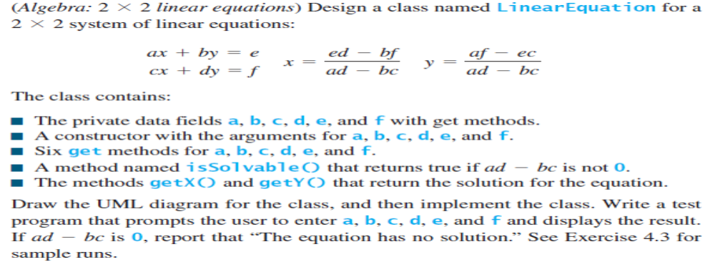
16 Write a test program that reads a matrix and displays the sum of each row &column.

17 (Sum the major diagonal in a matrix) Write a function that sums all the numbers of the major
diagonal in an matrix of integers using the following header:
def sumMajorDiagonal(m):
The major diagonal is the diagonal that runs from the top left corner to the bottom right corner in the square
matrix. Write a test program that reads a matrix and displays the sum of all its elements on the major diagonal.
18 (Locate the largest element) Write the following function that returns the location of the largest element in a two-
dimensional list:
def locateLargest(a):
The return value is a one-dimensional list that contains two elements. These two elements indicate the row and
column indexes of the largest element in the two-dimensional list. Write a test program that prompts the user
to enter a twodimensional list and displays the location of the largest element in the list.
19 Given the unsorted list [6, 5, 4, 3, 7, 1, 2], show what the contents of the list would be after each
iteration of the loop as it is sorted using the following:
a. Selection sort
b. Insertion sort
20 Your job is to come up with tests for a function called line_intersect, which takes two lines as input
and returns their intersection.
More specifically:
• Lines are represented as pairs of distinct points, such as [[0.0, 0.0], [1.0, 3.0]].
• If the lines do not intersect, line_intersect returns None.
• If the lines intersect in one point, line_intersect returns the point of intersection, such as
[0.5, 0.75].
• If the lines are coincident (that is, lie on top of one another), the function returns its first
argument (that is, a line).
21.Write a Program that rotates the elements of a list so that first index move to the second and so on and
last index move to first place.

22. Write a Program that creates a list of first 19 terms of Fibonacci series.
23. Creates a dictionary whose key are month names and whose values are number of days
corresponding days .print all the key in ascending order.

24. WAP to perform binary search .

25.WAP to take 10 pair of points and display the shortest distance pair.

SQL
Q 1
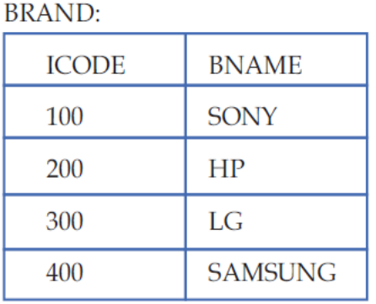
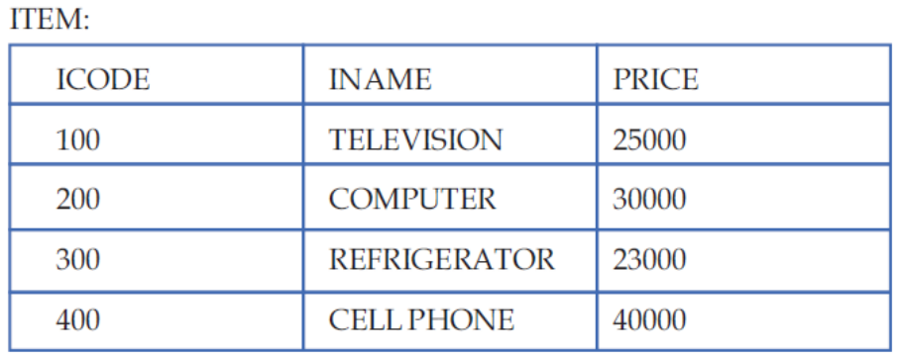
Q1 Write MYSQL queries for the following:

a) To display Iname, price and corresponding Brand name (Bname) of those items, whose price is
between 25000 and 30000 both values inclusive).

b) To display ICode, Price and BName of the item, which has IName as "Television".

c)To increase the Prices of all items by Rs. 10%.

d)(i) Display all students' information.
(ii) Display Rohan Saini's information.
(iii) Display number of students in the table.
(iv) Display number of students in each sex.
(v) Display students' information in ascending order using name.

Q2 1)Display students' information, whose average marks are in between 80 to 90.
2)Display students' name starting with letter "K".
3)Display students' information, whose name ends with "l".
4)Display a report with adno,name,average*5 as total marks from student table.
5)Display students' information, whose average marks are in between 80 to 90.

